|  |  |
| --- | --- |
|  | U:\ICMS_Logo\icms_logo_RGB.jpg |

**Seminar on:**

**Upcoming Opportunities in Autonomous Ship, Marine Insurance and Southeast Asia**

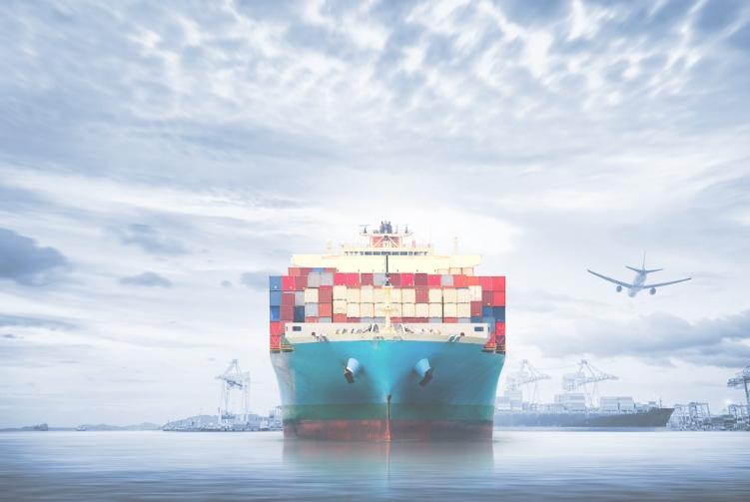

**Date: 22 Nov 2018 (Thursday)**

**Time: 19:00-21:30**

**Venue: Room FJ301, Poly U**

Enquiry: Please contact Miss Vera Tsui via [vera.tsui@polyu.edu.hk](mailto:vera.tsui@polyu.edu.hk)

or 27667416

|  |  |  |
| --- | --- | --- |
| [PolyU Website – Index Page](https://www.polyu.edu.hk/web/en/home/index.html) | [https://fb.polyu.edu.hk/media/1185/ifspa-logo-02.png](https://fb.polyu.edu.hk/) | **LMS_logo** |

**Keynote speakers:**

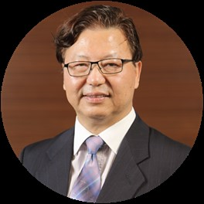

**Dr. Stephen Li**

**Topic: Loss and Indemnity in Marine Insurance**

Dr. Stephen Y K Li spent ten years at sea as Master and Deck Officer in the Merchant Navy. He joined the Marine Department of Hong Kong in 1987 and has served as a number of posts as examiner for masters and mates, marine accident investigation and a General Manager of the Shipping Registry.  Dr. Li has attained the degree in Doctor of Philosophy in 2002 with the University of Plymouth in the United Kingdom.  After retirement from Marine Department, he obtained the qualification as Barrister of the High Court in 2017.

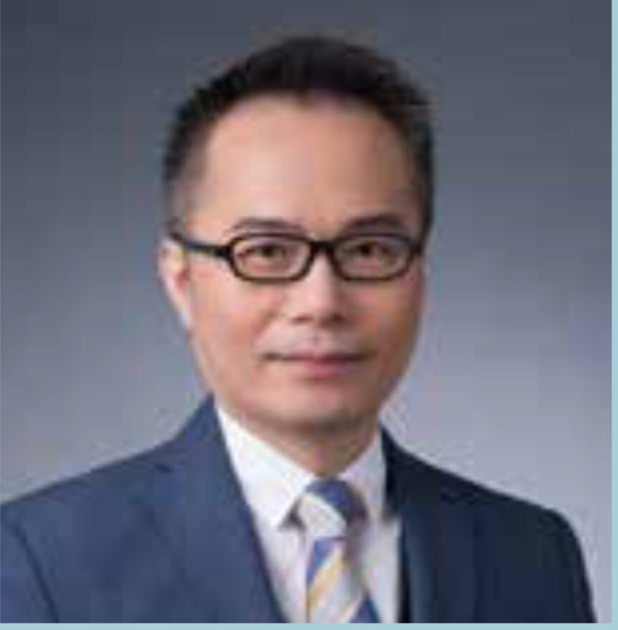**Dr. Simon Su**

**Topic: Port Development in Southeast Asia and “One Belt One Road”**

Dr. Simon Su is the Managing Director of ASA Projects Ltd. He has more than 2 decades' industry and research experience, and is an economist and a strategist by training. He was previously the Director and Chief Economist of BMT Asia Pacific for 10 years and the General Manager of GHK (Hong Kong) Ltd., where he spent over 7 years.

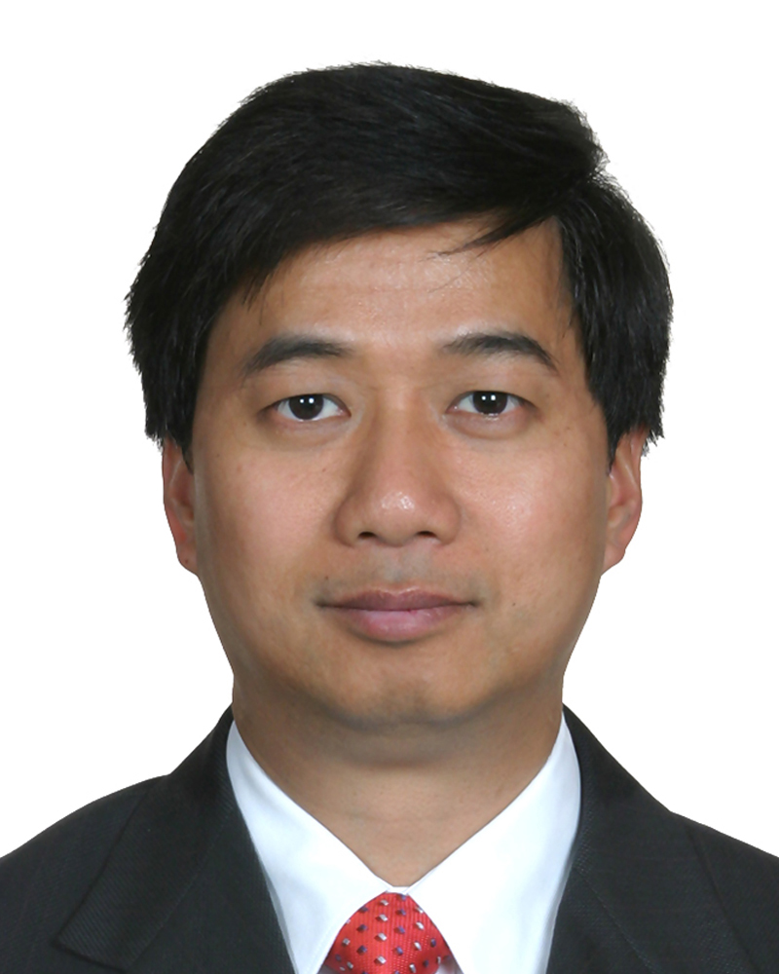

**Dr. Fung Ka Shuen**

**Topic: Maritime Autonomous Ship - its Implementation and Opportunities for Hong Kong**

Dr. Fung is interested in marine engineering. He is a Committee Member of Hong Kong Institute of Marine Technology since 2001 and became the Hon. Secretary since 2009. He has various publications on MARPOL and marine engineering; and received ECF for studying marine emission at container terminal. He was the Hon Secretary of the international conference 7th Pan Asian Association of Maritime Engineering Societies (7th PAAMES), Advanced Maritime Engineering Conference 2016 (AMEC2016) held in Hong Kong.

**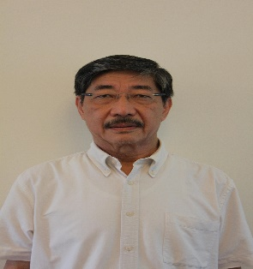Moderator:**

**Mr. Wong Cho Hor**

Mr. Wong Cho Hor is a Director of Five Oceans Maritime since the Company started. He reads Economics and International Relations at University College London and is responsible generally for all aspects of ship-management and logistics business, but in particular for all corporate, legal, insurance and project financing matters. He is currently an executive committee member of the Hong Kong Logistics Management Staff Association. He was appointed Sector Specialist for Transport & Logistics by the Hong Kong Council for Accreditation of Academic Qualifications until 30 June 2010. He currently specializes in the Belt & Road Initiative with his BRI General Theory (BRIGT) released on 22nd June 2018.